- What is version control?
- Version control (also called source control) is a system that helps manage changes to files over time.
- It allows multiple people to work on the same project, keeps a complete history of changes, and enables you to go back to earlier versions whenever needed.
- Version control is essential for tracking changes in source code.
- It can also be used for documents, images, configuration files, and more.

- Why is version control needed?
- ServiceNow development involves continuous changes such as:
- Business Rules
- Script Includes
- Client Scripts
- UI Policies
- Workflows / Flow Designer flows
- Catalog Items

- Without version control:
- Changes may get overwritten
- Old logic may be lost permanently
- It becomes difficult to identify what changed and why
- Two developers modify the same script unknowingly
- Latest update overwrites another developer’s work
- No visibility of parallel development

- Version control keeps a history of every change, allowing developers to:
- Compare previous and current versions
- Restore an earlier working version if an issue occurs

- How does one achieve version control?
- Version control is achieved by using structured tools, processes, and best practices that record changes, manage versions, and control deployments across instances (DEV → TEST → PROD).
- In ServiceNow, this is achieved through a combination of platform features and external tools.

- What are Update Sets?
- Update Sets in ServiceNow are a built‑in mechanism used to track, package, and move configuration changes from one instance to another (for example, from Development → Test → Production).
- Records:
  - What was changed
  - When it was changed
  - Who made the change

- Why and how update sets do not provide true Version Control in ServiceNow?
- Update Sets are change-tracking and migration tools, not version control systems. They record that a change happened, but they do not manage versions of code or configuration over time.

- How Update Sets Work
  - Update Sets Use “Last Write Wins”
    - When committing:
      - The incoming update:
        - Overwrites the existing record
      - There is no merge logic
    - If two developers:
      - Modify the same Business Rule
      - Export separate update sets
    - Then:
      - Whichever update set is committed last overwrites the other

  - Internal Mechanism
    - When you modify a configuration record (Business Rule, Script Include, Field, etc.)
    - ServiceNow:
      - Captures a snapshot of the record
      - Stores it as an Update Set XML entry
      - Associates it with the current update set
    - This is a single-state snapshot, not a version chain.

- How Version Control Works
  - True version control systems (Git, SVN):
    - Store every version of a file
    - Maintain a history timeline
    - Allow:
      - Compare v1 vs v5
      - Restore any previous version
      - Track incremental changes

- How Update Sets Fail Here
  - Update Sets only store:
    - The latest state of a record at the time it was captured
    - They do not store multiple versions of the same record
  - Business Rule edited 5 times
    - Update Set captures only the final version
    - Previous 4 versions are lost

- Why Update sets fail!!!
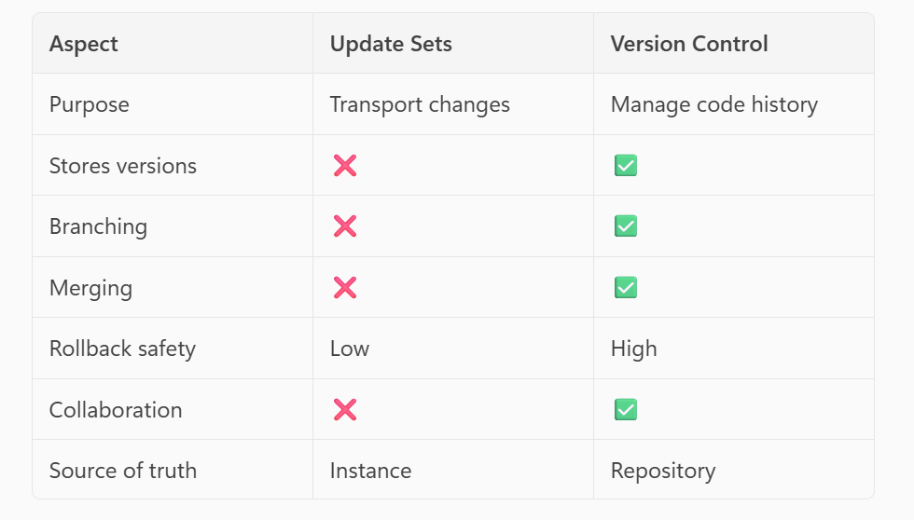

- How does ServiceNow adhere to true version control?
- By combining platform‑native change tracking, application versioning, and external source control (Git) to ensure history, traceability, isolation, rollback, and controlled releases.
- However, Update Sets alone are not true version control.
- Source Control plugin in ServiceNow Studio
- CI/CD pipelines (ServiceNow DevOps)

- How is this a drawback that the previous versions do not move across instances? Say, a business rule is drafted for its final version, and no further changes is needed, and it is moved from one instance to other. How the prior version will impact? Although the only version that matters is the final and current version which is captured in the update set.
- This Scenario (Perfectly Valid)
  - “A business rule is drafted to its final version, no further changes are needed, and it is moved across instances.”
- In this case:
  - Only the final version matters
  - The Update Set captures exactly what is required
  - No rollback is needed
  - No comparison is needed
  - No audit inquiry occurs
  - Update Sets work perfectly for this scenario

- Where the Absence of Previous Versions Does Matter
  - Rollback in TEST or PROD (Most Common Problem)
    - Scenario
      - Business Rule v5 is deployed to PROD
      - A production issue occurs:
      - Performance degradation
      - Wrong condition logic
      - Unexpected data update

    - Question:“Can we roll back to v4?”
    - Reality with Update Sets
      - v4 does not exist in PROD
      - Audit history didn’t move
      - Update Set has only v5
    - You must:
      - Re-write logic manually from memory
      - Or reconstruct it from DEV history

  - Parallel Development (Very Common)
    - Scenario
      - Feature A modifies the Business Rule
      - Feature B modifies the same Business Rule
      - Both are in different Update Sets
    - Problem
      - Update Sets are state-based
      - The last one imported wins
      - Earlier logic may be silently lost

